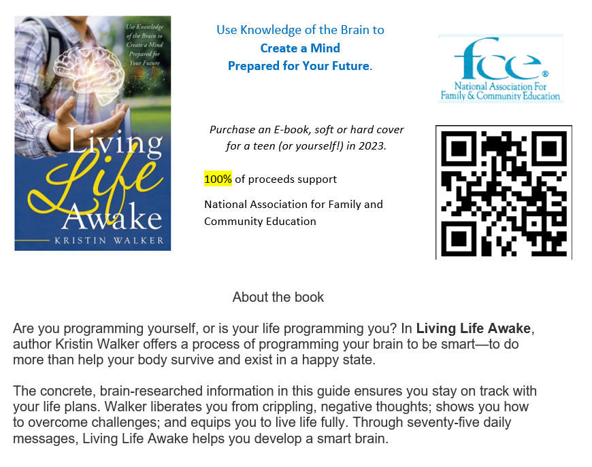

Dates of Fundraising: January 2023 to June 2023
- Share on Facebook
- Email to friends
- Copy flyer and give to others

Questions? Contact Kristin at kristinfce@yahoo.com
Kristin Walker
I am from West Virginia and love traveling with my husband of 29 years. My two daughters are married and established in careers; my son is in college. Professionally, I am an Early Childhood Specialist; I’ve taught in public schools as a pre-k, autism, and (presently) kindergarten teacher.
I was drawn to the organization because of FCE’s commitment to supporting families through education. I have been a member of West Virginia and NAFCE since 1998. As I learned in my research of the brain, our memories and education are extremely critical to healthy development.
In addition to supporting various health projects in our club, I organized an annual day for families. At this event, community organizations prepared activities for children ages 4-11 and provided families with information. Each year focused on a different area of development: physical health, intellectual development, social and emotional skills, and reading.
I began serving on the national board as the Young Families’ Coordinator. Later, I served as the VP for Programs. During these years I helped write programs to help parents encourage reading. I also worked on Family ChoicE Media.
Concerned about the impact of media and culture on youth, I began writing a book. Finally, in 2021 I published it. Living Life Awake is informative about how our brain works. With this information, I share how this affects our minds (thinking process). Finally, I provide practical steps for developing thinking habits that will be most beneficial to us in life. The brain is designed to help us live easily. Unfortunately, sometimes the best things for us to do our difficult. Living Life Awake teaches you how to make the most of life by mastering the brain.

