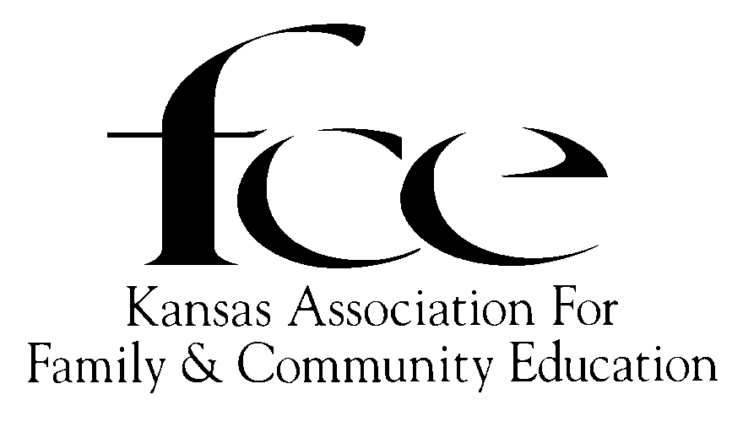

August, 2025

Dear Board of Directors,

The “2026 Tool Kit” (aka “August Mailing”) is emailed to each of you for your inspection and information. I want to emphasize the importance of this August Mailing, just as those before me have worked very hard to make improvements, answer questions, and share concerns with others so our members will be better informed.

Please take the time to read the forms and information provided. Some have been updated, some have been changed and there are new forms or information available. I appreciate the knowledge and guidance that you will share with the members.

This being my first attempt to send out the “Tool Kit”, I hope that it will be complete, and will answer the questions that the members may have. If a member does not find the answers or solutions to a situation, they may contact me.

Included, with the packet, will be the letters to the County FCE Council Presidents, Independent Members, and K-State Extension Agents.

I hope to see you at State Conference, October 9 to 11, 2025 in Dodge City, where we can greet and meet each other again. I'm looking forward to seeing all of you.

Sincerely Yours,

Faye Spencer

Kansas FCE State President

520 Gail Drive

Salina, KS 67401-7827

785-201-2143

Spencerf.kafce@gmail.com