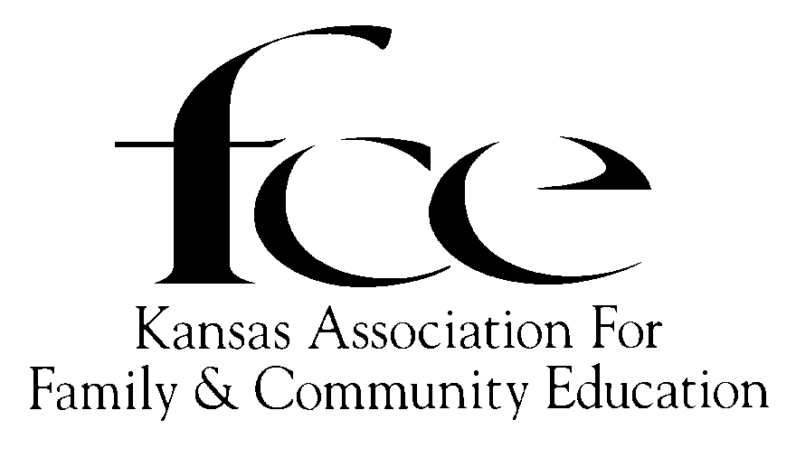

**KANSAS ASSOCIATION FOR FAMILY AND COMMUNITY EDUCATION**

**JOANN NEWBY ADULT EDUCATION GRANT GUIDELINES**

**PURPOSE**: The Joann Newby Adult Education Grant is provided for financial assistance to a recipient wishing to “reenter” the labor force; enable the recipient to move to a higher level employment in present field or to an occupation in a more highly skilled field.

**AMOUNT**: The amount of the grant shall be determined by the Kansas FCE Board of Directors. Funds for this grant are provided through voluntary contributions from Kansas FCE members.

**ELIGIBILITY:**

1. Be a resident of Kansas. There shall be no age limit.
2. Applicant must clearly indicate need of financial aid to obtain the necessary education training described in item C.
3. Applicant must clearly indicate the specific education necessary for reentry into the labor force and/or degree to which it will enable applicant to move to a higher level employment in present field or to an occupation in a more highly skilled field.
4. Applicant must enroll for a minimum of 9 hours in an accredited 2 or 4 year Kansas college or university or be enrolled as a full-time student in a Kansas vocational/technical program and maintain a 2.0 GPA on 4.0 scale.
5. The recipient of the Joann Newby Adult Education Grant must furnish the Kansas FCE President with proof of enrollment of the school attending. This would include college financial department contact information and college student identification number.
6. Money will be sent to the school in two installments, half each semester.
7. Provide all requested information to the Kansas FCE President by June 1.

**PROCDEURE**:

1. Complete and sign application form, pages 2 & 3.
2. Write an information, one page letter, indicating the following:
   1. How you plan to use your updated skills in your chosen career.
   2. Why you need financial assistance to obtain this additional educational training.
3. Obtain and forward three letters of reference to Kansas FCE President.
4. Request an official transcript to be sent directly to Kansas FCE President.
5. If awarded the grant, further instructions will be given to obtain the funds: including proof of enrollment and college financial department contact information. Money will be sent to the school. Half will be sent each semester

**Deadline for application is June 1.** Please send all documentation to:

Kansas FCE President, Faye Spencer, 520 Gail Drive, Salina, KS 67401-7827; (785) 201-2143; Email: [spencerf.kafce@gmail.com](mailto:spencerf.kafce@gmail.com)



**KANSAS ASSOCIATION FOR FAMILY AND COMMUNITY EDUCATION**

**JOANN NEWBY ADULT EDUCATION GRANT APPLICATION FORM**

Name

(First) (Middle) (Last) (Spouse Name)

Mailing Address

Email Address Date of birth

Telephone (______) _______________________ County

Marital Status ___Single_____Married____Seperated______Divorced_____Widowed______

**Number of Dependents** ______**Give ages of Children if any**:

|  |  |  |
| --- | --- | --- |
| Name | Relationship | Age |
|  |  |  |
|  |  |  |
|  |  |  |
|  |  |  |
|  |  |  |

**Occupation Experience**:

|  |  |  |
| --- | --- | --- |
| Name and Address of Employer | Type of Employment | Dates |
|  |  |  |
|  |  |  |
|  |  |  |
|  |  |  |

**Education Experience**:

|  |  |  |
| --- | --- | --- |
| High Schools Dates | Colleges Dates | Other Dates |
|  |  |  |
|  |  |  |
|  |  |  |

Education Experience field(s) of study

Have you ever received a scholarship or fellowship? _______. If so, give source, amount, where and dates:

Further Education Plans:

What is your proposed field of study?

What specific certification or degree do you hope to attain?

How many hours do you plan to enroll in?

What school do you plan to enroll in? (name and address)

Approximate date of entry __________________________Completion____________________

**Deadline for application is June 1.**

**Please send all documentation to:**

**Kansas FCE President, Faye Spencer, 520 Gail Drive, Salina, KS 67401-7827; (785) 201-2143; Email:** [**spencerf.kafce@gmail.com**](mailto:spencerf.kafce@gmail.com)

I understand that if I am the recipient of the Kansas FCE Joann Newby Adult Education Grant, all application materials and supporting information becomes the property of Kansas FCE, and Kansas FCE shall have discretionary authority in all matters pertaining to the grant.

I, _______________________________,(print name) certify that the information given in this application is complete and accurate to the best of my knowledge, and I will notify Kansas FCE immediately if there are any changes.

Signature of Applicant Date