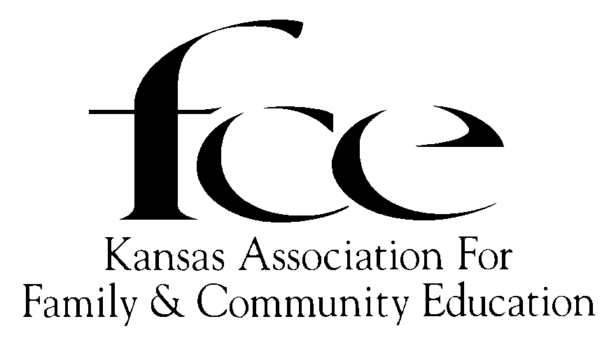
APPLICATION FORM FOR YEARS OF
MEMBERSHIP RECOGNITION
May be continuous or a combination of years

PRESENTED IN YEAR THAT IT IS ACHIEVED!

Applying for: (Circle year) 5 10 15 20 25 30 35 40 45 50 55 60 65 70 75 80 85 90 95 100…(in 5 year increments)

Member Name_________________________________ County

Street/PO Box #

City/State Zip Code + 4

FCE ID# Phone (_____) ____________________

Area (circle only one) NE NW SC SE SW

List name(s) of FCE(s) you have belonged to and the county & state where FCE(s) was located.
List the years you belonged to each FCE.

FCE Name County State Years of membership

____________________________ ________________ __________ _______ to ________

____________________________ ________________ __________ _______ to ________

____________________________ ________________ __________ _______ to ________

____________________________ ________________ __________ _______ to ________

Please share some special FCE memories.

APPLICANT – Send to County FCE Council President by October 1, 2021.

*County Council PRESIDENT – Send to KAFCE Area Director by November 1, 2021.
* Please refer to 2021 KAFCE Roster for Name & Address of each Area Director
KAFCE AREA DIRECTOR – Send form(s) to KAFCE Registrar by December 1, 2021.
KAFCE Registrar: DeLores Walden, 5720 SE Paulen Road, Berryton, KS 66409-9400
Revised 8/01/2019

