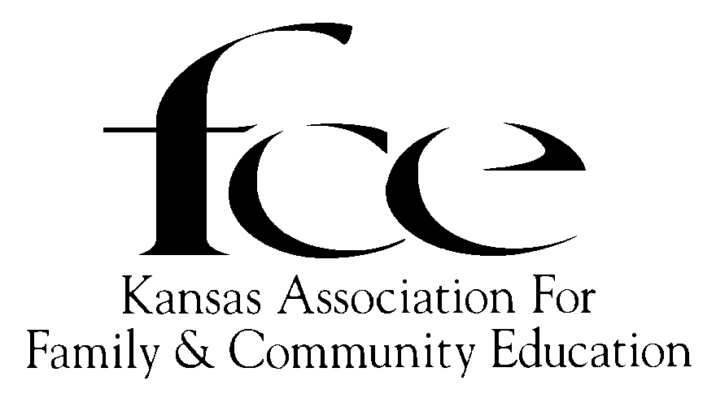
APPLICATION FORM FOR YEARS OF

FCE (group) RECOGNITION

PRESENTED IN THE YEAR THAT IT IS ACHIEVED!

APPLYING FOR: (Circle Year) 5 10 15 20 25 30 35 40 45 50 55 60 65 70
75 80 85 90 95 100 105 110…(in 5 year increments)

FCE Name__________________ County_____________ Area (circle) NE NW SC SE SW

Name of FCE Contact________________________________ Phone (_____) _____-

Street/PO Box #

City/State Zip + 4

Original Name___________________________________ Year Chartered _______ to________

Name__________________________________________ Year Re-chartered______ to _______
Please list (3) outstanding accomplishments.

1.

2.

3.

APPLICANT- Send to County FCE Council President by October 1, 2021.
*County Council PRESIDENT: Send to KAFCE Area Director by November 1, 2021.
* Refer to KAFCE Roster for Name & Address of each Area Director
KAFCE AREA DIRECTOR: Send forms to KAFCE Registrar by December 1, 2021.

KAFCE Registrar: DeLores Walden, 5720 SE Paulen Road, Berryton, KS 66409-9400
(Revised 08/01/2019)

