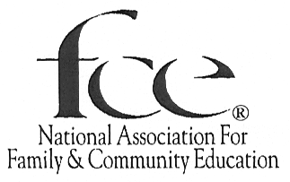

FCE Recognition: ______ Year

This form is for individual members and groups to evaluate their involvement and learn of the possible options to make a difference in the community.

To recognize your achievements, you will receive a certificate and be recognized at the National FCE Conference and on the National website.

- Review the items on page 2.
- Mark the activities that you have completed.
Note: Some activities may not be applicable to you or your group.
- To report your progress, send this form to:

NAFCE Headquarters.
73 Cavalier Blvd. Suite 106
Florence, KY 41042-5178

Deadline: Postmarked by April 15th

(Please type or print clearly)

Contact person name: _____________________________ State: ________________
FCE Group Name: ______________________ Number of members: ______________
Street/Box #: __________________________________________________________
City/State/Zip Code: ____________________________________________________
Telephone: (_____) -______-_________ E-mail: _______________________________

If this is a report about an individual’s involvement, please mark box:

In what ways were you involved this year?
(Indicate by check √ mark each task that a member or group completed)

EDUCATION
__ Use a National FCE Hearth Fire
__ Use a second National FCE Hearth Fire
__ Use a local Education program
__ Use a second local Education program
__ Use an ACWW Program
__ Share at least 1 local program/lesson with another group
__ Share at least 1 National/ACWW lesson/program with another group
__ Promote Awareness of Human Trafficking
__ Use NAFCE’s: CHARACTER COUNTS! ® Pillar lesson for the current year
__ Use NAFCE’s friends’ storybook

LEADERSHIP
__ Use FCL materials
__ Discuss a state, national, or international newsletter
__ Submit completed National FCE Program/Activity Report
__ Promote FCE in the Media (Social, TV, radio, newspaper, display at community event/location)
__ Promote National FCE Week October
__ Participate in ACWW’s Day of the Family or Women Walk the World
__ Attend a leadership training
__ Attends and reports on the State Conference and/or NAFCE Conference
__ Serve as elected or appointed county, area or state FCE position
__ Provide leadership training in the community

ACTION
__ Meet at least six times during the year
__ Participate in a community service or submit Community Service Award
__ Volunteer to local agencies
__ Promote the 4th grade Essay and Art Contest
__ Participate in a literacy project
__ Participate in a Family ChoicE Media project
__ Contribute to NAFCE Funds/projects
__ Contribute to State Funds/projects
__ Contribute to ACWW Funds/projects
__ Gain one or more new members

Recognition Levels based on number of items completed in each category
Hearth Fire level 10 of 10 Oak Leaf level 9 of 10 Lamp level 7 of 10
Wheat Sheaf level 5 of 10

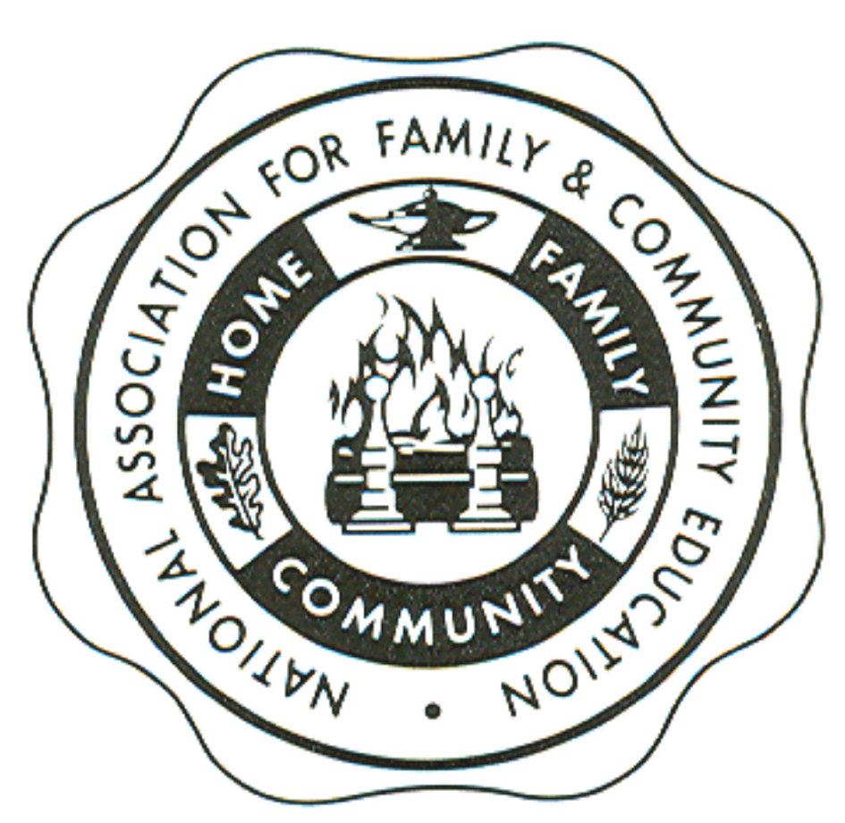

Congratulations and Thank You for all your work!

