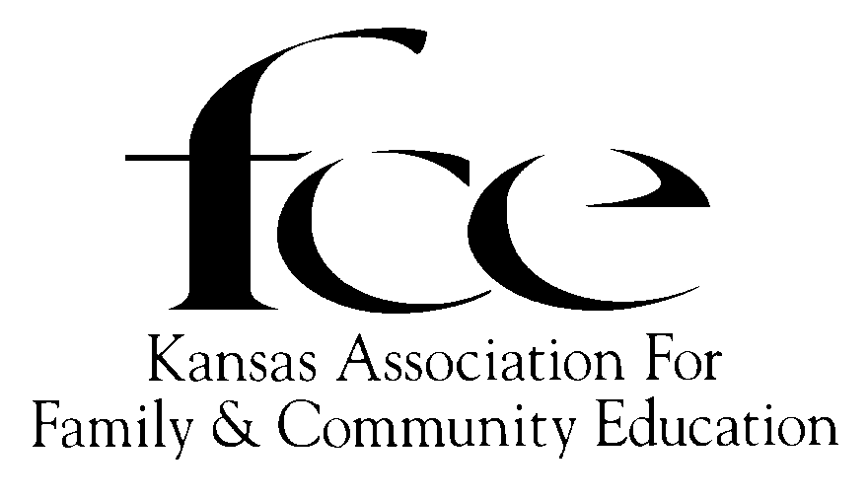 KANSAS ASSOCIATION FOR FAMILY AND COMMUNITY EDUCATION

2025 ___________________ COUNTY FCE COUNCIL or FCE UNIT OFFICERS **(Due to Area Director & State President by December 1)**

(County Name/AREA) KAFCE President Nancy Kernick, 628 S. Santa Fe, Chanute 66720

Name of County or District Extension FCS Agent ________________________________ (620) 433-1405 nancyavon78@gmail.com

Email of County or District Extension FCS Agent ________________________________

|  |  |  |  |  |  |  |  |  |  |  |
| --- | --- | --- | --- | --- | --- | --- | --- | --- | --- | --- |
| County Council / FCE Unit | Name | | Mailing Address  Street, CITY, STATE &  9-digit ZIP CODE | | Phone & e-mail | | Name of FCE UNIT | | Year term ends |  |
| President |  | |  | |  | |  | |  |  |
| Vice President |  | |  | |  | |  | |  |  |
| Secretary |  | |  | |  | |  | |  |  |
| Treasurer |  | |  | |  | |  | |  |  |
| Education Program Chair |  | |  | |  | |  | |  |  |
| NORTHEAST  Diane Nielson  1511 Atchison  Atchison, KS 66002-2245  C-(913) 488-5179  diane.nielson@yahoo.com | | NORTHWEST  Edith McClain  408 First Street  Gaylord, KS 67638-9748  (785) 697-2754  emcclain@ruraltel.net | | SOUTHCENTRAL  Linda Hess  1222 Nickerson St  Marion, KS 66861-1200  (620) 947-1627  lindalhess@hotmail.com | | SOUTHEAST  Cindy Kiser  220 North Grant St  Erie, KS 66733-1232  (620) 423-1766  tkiser2@cox.net | | SOUTHWEST  Connie Chavez  725 Atkin Streeet  Jetmore, KS 67854-9305  C-(303) 718-3349  chavez_17@msn.com | | |