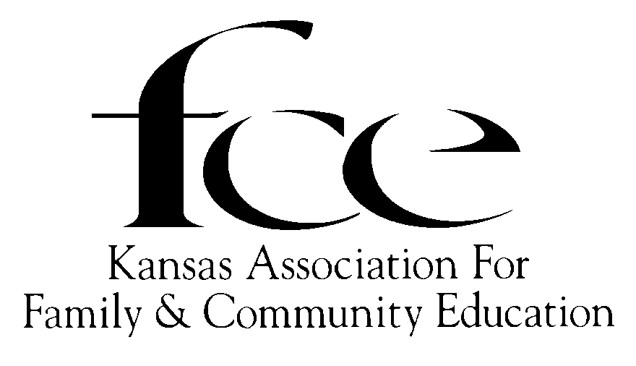
Proclamation
WHEREAS, the family is the core if society; and its well-being is dependent upon the development of the value system, and
WHEREAS, the mission of the Kansas Association for Family and Community Education is strengthening individuals, families and communities through: continuing education developing leadership community action; and
WHEREAS, the Kansas Association for Family and Community Education strives to promote a better way of life for all through fellowship, and service; and to provide guidance in our homes and communities by the uniting of people to make the world a better place in which to live; and
WHEREAS, they are proud of their role as homemakers and family and community volunteer educators and are always conscious of the needs of others; and
WHEREAS, the Kansas Association for Family and Community Education, with the National Association for Family and Community Education, who are an independent nonprofit organization instituted for the purpose of enriching families, join voices in promoting FCE Week; and
WHEREAS, during this year in 27 Kansas counties, 407 members in 40 FCE Units plus 24 Independent Members received continuing education through family and community education;

NOW, THEREFORE, I, ______(name) , __________(title), do hereby proclaim October 11-17, of 2026, as

KANSAS ASSOCIATION for FAMILY AND
COMMUNITY EDUCATION WEEK

in Kansas and urge all citizens to join in this observation.

