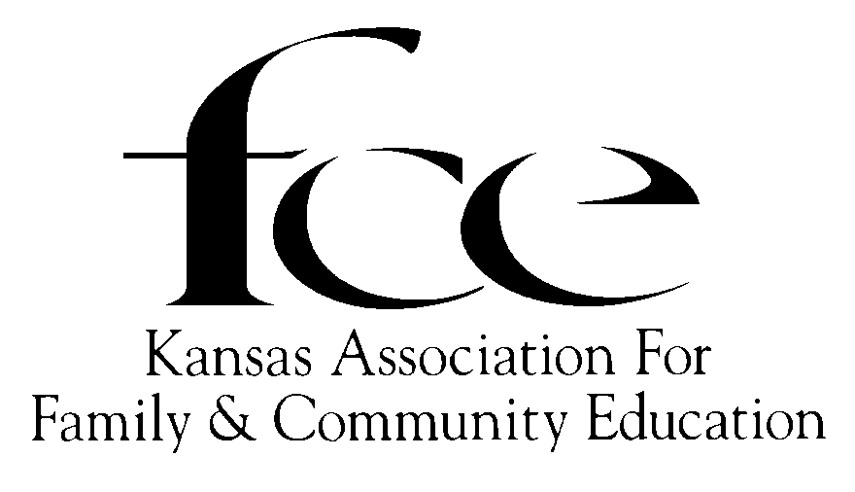

2026 ROSTER
BOARD OF DIRECTORS
Executive Committee

PRESIDENT VICE PRESIDENT
(25-27) Faye Spencer - SC - Saline (25-26) DeLores Walden - NE - Shawnee
520 Gail Dr, Salina, 67401-7827 5720 SE Paulen Road, Berryton, 66409-9400
C-785-201-2143 H: 785-379-0666; C: 785-215-4696
spencerf.kafce@gmail.com wintersdj1@ cox.net

SECRETARY TREASURER
(Registrar/Historian; Membership List/Records)
(26-28) Cindy Kiser - SE - Neosho (25-27) Marcy Price - SW - Ford
220 N. Grant St, Erie, 66733 11427 103 Rd, Ensign, 67841-9304
C: 620-423-1766 C: 620-255-2001
tkiser2@cox.net thesewinglady@yahoo.com
Area Directors

Northeast: (28) Diane Nielson, (Atchison), 59275 Shelby Rd, Milan, MO 63556; C - 913-488-5179; diane.nielson@yahoo.com.
Northwest: (28) Mona Grady, (Russell), PO Box 367, Russell, 67665-0367; C - 785-445-8421; mymonia_20052002@yahoo.com
South Central: (27) Kathy Preheim, (McPherson), 2008 50th, Peabody, 66866; C - 620-386-0778; kathypreheim@gmail.com.
Southeast: (27) Mary Dunn, (Neosho), 2320 Florida Rd, Humboldt, 66748; H-620-473-3521; C-620-433-1316; maryfdunn@yahoo.com
Southwest: (29) Connie Chavez, (Hodgeman), 725 Atkin St, Jetmore, 67854-9305; C-303-718-3349; chavez_17@msn.com (underscore between z and 1)

State Educational Program Committee
The member serves as State EPC Chair and receives the Accomplishment, Community Service Project and other reports the prior year listed before their name. State EPC Member’s term ends December 31 the year listed before their name.
(26) Susan Gartrell (NW/Rooks), 415 6 Road, Stockton, 67669-8810; 785-689-4820; gartrell@ruraltel.net
(27) Lois Carlson, (SE/Neosha), 422 West Wilder St., Erie, 66733’ C – 620-423-1004; jlcarlson14@cox.net
(28) Linda Hess, (SC/McPherson), 1222 Nickerson St., Marion 66861; (620)-947-1627; lindalhess@hotmail.com

Area Directors and Area EPC:
Area EPC Chair serves the year prior to the year listed before their name. Area EPC member’s term expires May 31 in the year listed. (2026 program year forms are to be sent to Area Director; the Area EPC Chair is whose term ends in 2027). Area Directors’ term expires December 31 in the year listed before their name.

Vice President (26) DeLores Walden, 5720 SE Paulen Road, Berryton 66409; H: 785-379-0666 C: 785 215-4696; wintersdj1@ cox.net
NORTHEAST
(26) AD Diane Nielson, 59275 Shelby Rd, Milan, MO 63556; C-913-488-5179; diane.nielson@yahoo.com.
(27) Anita Felzke, 15765 W. 199th Str, Springhill, 66083, 913-558-2682, afelzke@aol.com
(27) Lynne Cathey, 9919 W. 101st St., Overland, 66212, 913-744-8672 lynnecathey@yahoo.com
(28) Tina Bailey, 15112 142nd Rd, Mayetta, 66509-8795; 785-966-2457; tina_fce@yahoo.com
(29) Jeannie Flory, 9455 214th Road, Nortonville, jtflorys@gmail.com
(29) Amy Masters, 1701 215th Rd, Troy, 66087, 785-741-2490, amymasters403@gmail.com
NORTHWEST
(28) AD Mona Grady, (Russell), PO Box 367, Russell, 67665-0367; 785-445-8421; mymonia_20052002@yahoo.com
(27) Janie Lowry, 1045 11 RD, Stockton, 67669, Rooks Co, C-785-543-7709; janielowry20@yahoo.com
(28) Patricia Keas, 604 SW 9th St, Plainville, 67663-3402; 785-639-1423; prkeas@gmail.com
(29) TBA
SOUTH CENTRAL
(27) AD Kathy Preheim, 2008 50th, Peabody, 66866; McPherson Co; 620-386-0778; kathypreheim@gmail.com
(27) Adele Koehn, 918n24th Ave, Galva, 67443; McPherson Co; 620-654-7194; adelekoehn@gmail.com
(28) Bonnie Kaufman, 525 22nd Ave, Moundridge 67107, (620) 345-2522; msbeanie@mtelco.net
(29) Margaret Brewer, 3018 Ivy Dr., North Newton, 67117; 316-258-7767; margaret-brewer@att.net
SOUTHEAST
(27) AD Mary Dunn, 2320 Florida Rd, Humboldt, 66748; Neosho Co; H 620-473-3521; C: 620-433-1316 maryfdunn@yahoo.com
(27) Sharon Giacometti, 221 E. 670th Ave; Farlington, 66734; Crawford Co; 620-724-5303;sgiacometti@ckt.net
(28) Donna Strickland, 11058 Wallace Rd, Oswego 67356; Labette Co; 620-795-4469; Dsfun345@hotmail.com
(29) Glenda Miller, 1236 Fern Rd, Ft. Scott, 66701; 620-574-2401; goodwitchglenda17@gmail.com
SOUTHWEST
(29) AD Connie Chavez, 725 Atkin St, Jetmore, 67854; Hodgeman Co; 303-718-3349; chavez_17@msn.com
(27) Lisa Burdett, 9 43 N Rd, Larned 67550, Pawnee Co; 620-285-5830; mpb.dvm@sbcglobal.net.
(28) Connie Chavez, 725 Atkin St, Jetmore, 67854; Hodgeman Co; 303-718-3349; chavez_17@msn.com
(29) Ann Adams, 2960 Ave. M, Bison, 67520; Rush Co; 785-650-3261; adamsann014@gmail.com

2026 State Nominating Committee (Term: 1 year beginning January 1, elected at Fall Area Council Meeting.)
(26) CHAIR: SE - Ruth Shafer, 1262 CR 1700, Caney, 67333; C: 620-688-1101; royshafer@gmail.com
(26) NE - Amy Masters, 1701 215th Rd, Troy, 66087; 785-741-2490; almjrm1989@hotmail.com
(26) NW - Edith McClain, 408 1st St, Gaylord, 67638-9748; H-785- 697-2754; C-785-282-5734; emcclain@ruraltel.net
(26) SC - Margaret Brewer, 3018 Ivy Dr., North Newton, 67117; 316-258-7767; margaret-brewer@att.net;
(26) SE - Carol Stephens, 217 W 2nd St, Erie 66733-1310; no phone
(26) SW - Dorene Reimer, 1294 West County Road P, Leoti 67861-6247; 620-874-5062
ALTERNATES
(26) NE –
(26) NW – Janie Lowry, 1045 11 RD, Stockton, 67669, Rooks Co, C-785-543-7709; janielowry20@yahoo.com
(26) SC – Marlene Faul, 3000 Wildwood Way, North Newton, 67117; 316-288-9650; marlene.violet@gmail.com
(26) SE – Jennine Marrone, 1105 Canterbury Rd, Pittsburg 66762; C: 620-687-3582; jmarrone50@yahoo.com
(26) SW – Connie Yost, 31506 10 Rd, Montezuma, 67867; C: 620-290-0745; connie_yost@hotmail.com

Marketing Committee
Dorene Reimer, Chair Geneva Wedel Jennine Marrone
1294 West County Road P 86 22nd Ave # 109 1105 Canterbury Rd
Leoti, 67861-6247 Moundridge, 67107-7003 Pittsburg 66762
620-874-5062 C: 620-245-5517 H: 620-231-8942; C: 620-687-3582
dreimer@wbsnet.org (use lindalhess@hotmail.com) jmarrone50@yahoo.com

KAFCE Conference Committee Coordinators
2026 NE: Daine Nielson, Anita Felzke and Lynne Cathey
2027 SC: Kathy Preheim
2028 NW:
OTHER APPOINTED POSITIONS
Parliamentarian Webmaster / Editor (Kansas FCE News) William Allen White Children’s Book Award
Judy Fullmer Marcy Price (26) Denise Marcum NW
4250 County Road C 11427 103 Rd 503 Walnut St
Dighton, 67839-8801 Ensign, 67841-9304 Lebanon, 66950-8866
H: 620- 397-5938 C: 620-255-2001 C: 785-282-4142
C: 620-872-9990
jfullmer@st-tel.net thesewinglady@yahoo.com deniseincenter48@yahoo.com

Registrar/Historian and Membership List/Records duties will be done by the Treasurer.
American Income Life Insurance
Angela Engel– 580-541-2020 acengel@ailife.com

National FCE Headquarters
P. O. Box 642, Florence, KY 41042-0642; Phone: 859-525-6401 Judy Jones, Office Secretary
Office Hours: 10:00 am to 2:00 pm (ET) - Tues, Wed, Thurs; nafcehq@fuse.net www.nafce.org

National FCE Board Members from Kansas
Secretary - DeLores Walden (27) 5720 SE Paulen Road, Berryton, 66409-9400 H: 785-379-0666; C: 785-215-4696; wintersdj1@ cox.net
Public Policy Coordinator - Sharon Giacometti (27), 221 East 670th Ave, Farlington, KS 66734-4096;
H: 620-724-5303; C: 620-704-1554; sgiacometti@ckt.net
Bylaws - Peggy Martens, 822 Arrowhead Rd, Inman, KS 67546, C 620-242-2067; plvbmar@embarqmail.com; and Judy Fullmer, 4250 County Road C, Dighton, 67839, H: 620-295-1522, jfullmer@st-tel.net
Legacy Fund and Future of FCE – Dorene Reimer, 1294 West County Road P, Leoti, 67861-6247, 620-874-5062, dreimer@wbsnet.org
ASSOCIATED COUNTRY WOMEN of the WORLD (ACWW)
Jane Chapman (29), ACWW USA Area President, (Illinois), usa@acww.org.uk.
Personal email is ejanec50@gmail.com
K-State University Extension Advisor- www.ksu.edu
TBA, Associate Director, Extension Programs, K-State Extension,
101 Umberger Hall, 1612 Claflin Rd, Manhattan, 66506, Office: (785) 532-1562, email:
Kansas Extension Agents Family & Consumer Sciences Representative:
Liaison: Jessica Kootz, Midway District FCS Agent, 210 Kansas Ave, Suite 1, Ellsworth, 67439,
Office 785-472-4442; Cell 785-531-0069, jessicak@ksu.edu
K-State University Family and Consumer Science AREA Advisors
*NE Area Extension Specialist, Family & Consumer Sciences, Sharolyn Jackson, Area Office, 1007 Throckmorton Hall, 712 Claflin Road, Manhattan 66506; Phone: (785) 532-2273, sharolyn@ksu.edu
*NW Area Extension Specialist Family & Consumer Sciences, Jo Ellen Argabright, Rawlins County Extension, 406 State Street, Atwood 67730-1929; Phone: (785)626-3192; joargabright@ksu.edu
*SE Area Extension Specialist, Family & Consumer Sciences, Christina Holmes (cell 417-317-7257), PO Box 316, Parsons 67357-0316; Office: (620) 820-6123, christinaholmes@ksu.edu.
*SW Area Extension Specialist, Family & Consumer Sciences, Rachael Clews, MA, MS, CFLE, 4500 E. Mary St., Garden City 67846-9132; Phone: (620) 275-9164 x226, Cell: (469)233-1672; rclews@ksu.edu
*SC Area – Extension does not have a SC Area/Regional Office

2026 National and Kansas FCE Dates to Remember
July 20 to 23 National FCE Annual Conference, Holiday Inn, Erlanger, KY
August Kansas State EPC Leadership Training
March,6 June 5, September 25 Kansas FCE Board of Directors’ Meeting
October 6-8 Kansas FCE State Conference, Atchison
October 11-17 National FCE Week
November 22-28 National Family Week
2026 Area Council Meetings
 | SPRING | City | FALL | City
NE
NW |  | Rooks Co.
SC | April 14 | Moundridge | Oct | W. Zion Mennonite Church, Moundridge
SE | May 7 | Pittsburg | Nov 5 | KSU, SE Extension Center, Parsons
SW | April 23 | Rush Co. | Oct 15 | First Christian Church, Dighton

