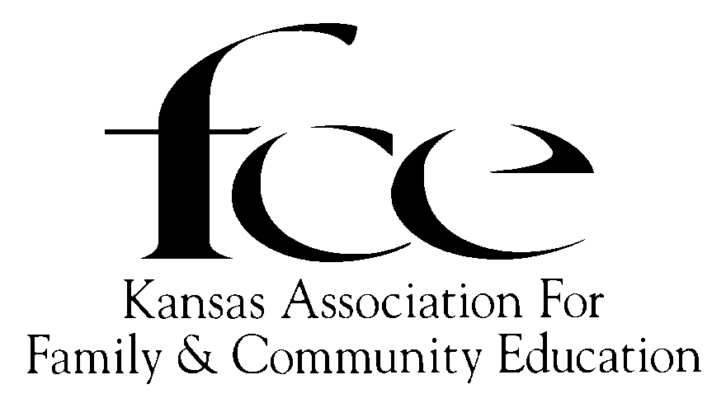 2022 ROSTER
(Updated August 1, 2022)
BOARD OF DIRECTORS

Executive Committee

PRESIDENT
(24) Nancy Kernick – SE Neosho
628 South Santa Fe Ave
Chanute 66720-2449
(620) 431-1353
nancyavon78@gmail.com

SECRETARY
(22) Marlene V. Faul – SC Harvey
3000 Wildwood Way
North Newton, 67117-8058
H-(316)-283-3342
marlene.violet@gmail.com

VICE-PRESIDENT
(22) Faye Spencer – SC Saline
520 Gail Dr
Salina 67401-7827
(785) 201-2143
spencerf.kafce@gmail.com

TREASURER
(24) DeLores Walden – NE Shawnee
5720 SE Paulen Road
Berryton 66409-9400
(785) 379-0666
wintersdj1@ cox.net

Area Directors

NorthEast NorthWest SouthWest
(22) Carol Lintner - Atchison (22?) Edith McClain - Smith (23) Karen Larmer - Finney
320 Parallel St 408 1st St 1218 Ridgewood Dr
Atchison 66002-1951 Gaylord 67638-9748 Garden City 67846-4552
C-(913)-370-3997 (785) 697-2754 C-(785) 443-0559
lintners@reagan.com emcclain@ruraltel.net kslarmer@yahoo.com

SouthCentral SouthEast
(24) Linda Hess – Marion (24) Cindy Kiser, Neosho
1222 Nickerson St 220 N Grant St.
Marion 66861-1200 Erie, 66733-1232
(620)-947-1627 (620)-423-1766
lindalhess@hotmail.com tkiser2@cox.net

2022 KAFCE Dates to Remember

September 19 KAFCE State EPC Leadership Training, Zoom
September 26 KAFCE Board of Director’s meeting, ZOOM
October 3-5 KAFCE State Conference – Newton
October 9-15 National FCE Week
November 20-26 National Family Week
NAFCE Headquarters
73 Cavalier Blvd. Suite 106, Florence, KY 41042-5178; Phone: 859-525-6401 Fax (859) 525-6496
Office Hours: 10:00 am to 5 pm- Tuesday, Wednesday, Thursday (Eastern Time)
nafcehq@fuse.net - www.nafce.org

NAFCE National
President Judy Fullmer (2024), (KS) 4250 County Rd C, Dighton 67839-8801,
H-620-295-1522, jfullmer@st-tel.net

NAFCE By-Law Committee – Connie Larrington, Judy Fullmer, Nancy Kernick

NAFCE National Board Member from Kansas
President Judy Fullmer (2024), 4250 County Rd C, Dighton 67839-8801, H-620-295-1522, jfullmer@st-tel.net
Legacy Dorene Reimer -1294 West County Road P, Leoti 67861-6247, 620-874-5062 mreimer@wbsnet.org
VP Programs: Peggy Martens (2024) 812 Arrowhead Road, Inman 67546, (620)585-2302
Program Coordinator Faye Spencer (2023), 520 Gail Dr, Salina, 67401-7827, 785-201-2143 spencerf.kafce@gmail.com

ASSOCIATED COUNTRY WOMEN of the WORLD (ACWW)
Bonnie Teeples, ACWW USA Area President, (OR), 541-891-2662 (PT); bdteeples@charter.net

K-State University Research & Extension Advisor- www.ksu.edu
Rick Peterson, PhD., Associate Director, Extension Programs, K-State Research & Extension,
340 Justin Hall, Manhattan, 66506, Office: (785) 532-1562, email: rlpeterson@k-state.edu

Kansas Extension Agents Family and Consumer Sciences (KEAFCS) Representative:
Liaison — TBA

K-State University Family and Consumer Science AREA Advisors
*NE Area Extension Specialist, Family & Consumer Sciences, Sharolyn Jackson, Area Office, 1007 Throckmorton Hall, 712 Claflin Road, Manhattan 66506; Phone: (785) 532-2273, sharolyn@ksu.edu
*NW Area Extension Specialist Family & Consumer Sciences, Jo Ellen Argabright, Rawlins County Extension, 406 State Street, Atwood 67730-1929; Phone: (785)626-3192; joargabright@ksu.edu
*SE Area Extension Specialist, Family & Consumer Sciences, TBA, PO Box 316, Parsons 67357-0316; Office: (620) 421-4826,
*SW Area Extension Specialist, Family & Consumer Sciences, Rachael Clews, MA, MS, CFLE, 4500 E. Mary St., Garden City 67846-9132; Phone: (620) 275-9164 x226, Cell: (469)233-1672; rclews@ksu.edu
*SC Area – Extension in Kansas does not have a SC Area/Regional Office

STANDING COMMITTEES

State Educational Program Committee
STATE EPC MEMBER’S term ends December 31 the year listed before name. The third and final year, member serves as State EPC Chair and listed on the Accomplishment Report the prior year.
(22) Cindy Kiser – SE Neosho (23) Tina Bailey – NE – Jackson (24) Jennine Marrone-SE - Crawford
220 North Grant St. 15112 142nd Rd 602 Villa Dr
Erie 66733-1232 Mayetta 66509-8795 Pittsburg, 66762-3581
(620) 423-1766 (785) 966-2457 (620) 231-8942
tkiser2@cox.net tina_fce@yahoo.com jmarrone50@yahoo.com

(25) Ruth Shaffer, SE, Montgomery, 1252 CR 1700, Chaney, 67333, H-620-879-2065; royshaffer@gmail.com

2022 State Nominating Committee (Term June 1 prior year to May 31, year listed below.)

(23) CHAIR: NE –Pat Weishaar -1108 Hwy 24, St. Marys, 66536-9780 pweishaar2016@outlook.com (785)-437-3160
(22) NE –Diane Hanzlicek - 304 Harrison St, Sabetha 66534-2204. dianeflood@sbcglobal.net (785)-284-2776
(22) NW –Ellen Schmidt -1464-B Hopewell Rd, Hays 67601-9723 cykill1@yahoo.com (785)-735-4326
(22) SC -Geneva Wedel – 1712 Magnolia Village, Moundridge 67107-7005 (no email) (620)-245-5517
(22) SE – Sharon Giacometti - 221 East 670th Ave- Farlington, 66734-7827 sgiacometti@ckt.net (620)724-5303
(22) SW –Janice Baca - 14526 NW O Rd, Jetmore, 67854-5333, - kreger@fairpoint.net (620)357-6106

ALTERNATES
(22) NE –Lynn Cathey, 9919 W. 101st St, Overland Park, 66212-5402 lynnecathey@yahoo.com (913)-744-8672
(22) NW -Louise Greenberg -218 East Court St, Smith Center, 66967-2704 gberg@ruraltel.net (785)-282-6822
(22) SC –Jean Rowland – 711 Hunter Court, McPherson, 67480-1731 jrowland@ksu.edu (620)-241-1751
(22) SE -
(22) SW – Dorene Reimer, 1294 W. County Road P, Leoti, 678616247, mreimer@wbsnet.org (620) 874-5062

Marketing Committee
Dorene Reimer, Chairman Geneva Wedel Jennine Marrone
1294 West County Road P 1712 Magnolia Village 602 Villa Dr
Leoti, 67861-6247 Moundridge, 67107-7005 Pittsburg 66762-3581
(620) 874-5062 cell: (620) 245-5517 (620) 231-8942
mreimer@wbsnet.org (no e-mail) jmarrone50@yahoo.com

KAFCE Conference Committee Coordinators
2021- NE – DeLores Walden - 5720 SE Paulen Road, Berryton 66409-9400 (785)379-0666
And Tina Bailey – 15112 142nd Road, Mayetta 66509-8795 (785)966-2457
2022-SC – Marlene V. Faul, 3000 Wildwood Way, North Newton 67117-8058, 316-283-3342, marlene.violet@gmail.com
2023 – NW Edith McClain

OTHER APPOINTED POSITIONS
PARLIAMENTARIAN EDITOR – KAFCE NEWS & Webmaster WILLIAM ALLEN WHITE
(22) Judy Fullmer Marcy Price (23) Anita Felzke
4250 County Road C 11427 103 Rd 15765 W 199th St
Dighton, 67839-8801 Ensign, 67841-9304 Spring Hill 66083-8527
H-(620) 295-1522 (620) 255-2001 (913) 558-2682
jfullmer@st-tel.net thesewinglady@yahoo.com afelzke@aol.com

REGISTRAR/HISTORIAN/
MEMBERSHIP LIST/RECORDS
(22) DeLores Walden
5720 SE Paulen Rd
Berryton, 66409-9400
(785) 379-0666
wintersdj1@cox.net
Area Directors and Area EPC (updated April 27, 2022)
Area EPC Chair serves the year prior to year listed before name. During year listed before name, term expires May 31 for Area EPC; Dec. 31 for Area Director.
VICE-PRESIDENT, (22) Faye Spencer, 520 Gail Dr., Salina 67401-7827, 785-201-2143; spencerf.kafce@gmail.com

NORTHEAST
(22) AD: Carol Lintner, 320 Parallel St, Atchison 66002-1951 Atchison H (913)-367-2178
lintners@reagan.com C (913)-370-3997
(23) Sally Banks, 3982 St. Hwy 116, Holton 66436-8030 Atchison H (785)-872-3558;
sallyb@rainbowtel.net C (785)-851-9399
(24) Cheryl Anne Reves, 22300 Spring Creek Rd, Frankfort 66427-8975; Pottawatomie; C (785)-562-7524. careves@ksu.edu
(25) Tina Bailey, 15112 142nd Rd, Mayetta, 66509-8795, Jackson 785-966-2457, tina_fce@yahoo.com
NORTHWEST
(24) AD: Edith McClain, 408 1st St, Gaylord 67638-9748 Smith H (785) 697-2754
emcclain@ruraltel.net
(23) Susan Gartrell, 415 6 Road, Stockton 67669-8810 Rooks (785) 689-4820
gartrell@ruraltel.net
(24) Diane Hrabe, 1004 SW 8th St, Plainville 67663-3104 Rooks (785)-737-3939
dianehrabe@gmail.com
(25) Eleanor Wherry, 2365 21 Rd, Plainville 67663-9253 Rooks 620-232-4202
eewherry@gmail.com
SOUTH CENTRAL
(24) AD Linda Hess, 1222 Nickerson St, Marion, 66861-1200 Marion (620) 947-1627
lindalhess@hotmail.com
(23) Nyla Stucky, 2056 Cherokee Rd, Moundridge 67107-7480 McPherson H (620)345-8456
(24) Lory Fisher, PO Box 884, Moundridge, 67107-0884 McPherson (620)-794-6125
fisherlory@gmail.com
(25) Beverly Nickel, 8710 SE 24th St, Newton 67114-9619 Harvey H-316-283-1113
dbnickel49@gmail.com C-316-243-8777
SOUTHEAST
(24) AD Cindy Kiser, 220 N Grant St, Erie 66733-1232 Neosho (620)-423-1766
tkiser2@cox.net
(23) Carol Stephens, 217 W 2nd St, Erie 66733-1310; tcms@cox.net Neosho (620) 432-4028
(24) Mary Dunn, 2320 Florida Rd, Humboldt, 66748-1091 Neosho H (620)473-3521
maryfdunn@yahoo.com C (620)433-1316
(25) Donna Strickland, 11058 Wallace Rd, Oswego 67356-8734 Labette 620-795-4469
Dsfun345@hotmail.com
SOUTHWEST
(23) AD Karen Larmer, 1218 Ridgewood Dr, Garden City 67846-4552 Finney (620)272-0050
kslarmer@yahoo.com
(23) Marcy Price, 11427 103 Rd, Ensign, 67841-9304 Ford (620) 255-2001
thesewinglady@yahoo.com
(24) Leanna Adams, 2113 N. C St., Garden City 67846-2901 Finney (785)-443-0688
leanna54@gmail.com
(25) Connie Chavez, 725 Atkin St, Jetmore, 67854-9305 Hodgeman 303-718-3349
chavez_17@msn.com

