2025 Accomplishment Report:
Completed by (Check one) ____ FCE Unit; _____County Council; ____ Independent Member
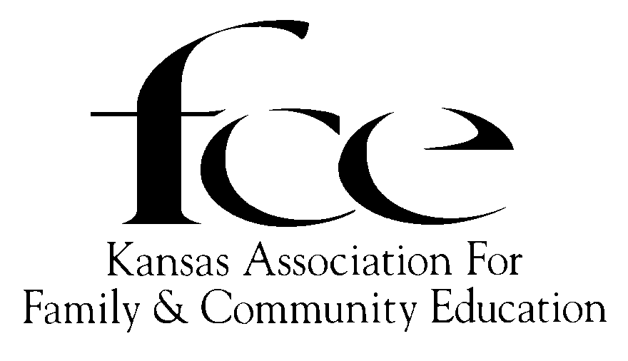

(Please complete using black or red ink.)
County: ________________________________ AREA (Check one): ___ NE; ___ NW; ___ SC; ___ SE; ___ SW
Name: Independent Member/FCE Unit/County Council:
Number members: In FCE Unit ________; In County: ___________; Number of Units in County
Report submitted by:
Complete Mailing Address:
Phone: _____________________ Email:
<<<<<<< Please, SAVE a copy of this report for your own records. >>>>>>

Kansas FCE Summary of Programs by Category of ALL LESSONS | Number of FCE Presenters | Number of FCE Hours Volunteered | Number of FCE Members Reached/Involved | Number of Other People Reached (lessons, media, booth, displays) | FCE $ Spent (include value if donated)
“E” Education
“L” Leadership
“A” Action
Totals
Check Mark either A or B A. ____ DO Judge; B. ______ DO NOT Judge.

Due By December 1: FCE Units send to County EPC. Independent Members send to State EPC Chair.
Due By January 1: County EPC: Forwards ALL forms (judged/not judged) to AREA EPC, See list below.
Due By February 1: Area EPC: Forwards ALL forms (judged/not judged) to State EPC Chair.
Due By March 1: State EPC chooses FCE Unit, Independent, & County Council state winners in each category.

(26) NE: Margaret Barnes, 727 E 1650 Rd, Baldwin City, 66006; H: 785-594-6408; mbarnes1830@gmail.com
(26) NW: Susan Gartrell, 415 6 Road, Stockton, 67669; H:785-689-4820; gartrell@ruraltel.net
(26) SC: Mary Hammond, 815 Pentwood Dr, Salina, 67401; C: 785-829-7798; mcawichita@yahoo.com
(26) SE: Linda Dunekack, 1107 Twin Lakes Dr, Pittsburg, 66762; H: 620-232-0543; lindadunekack@gmail.com
(26) SW: Ann Adams, 2960 Ave. M, Bison, 67520; H: 785-650-3261; adamsann014@gmail.com
(26) State EPC Chair: Susan Gartrell, 415 6 Road, Stockton 67669; H: 785-689-4820; gartrell@ruraltel.net

100% Reporting AND Accomplishment Award: Please complete both pages following given outline about one lesson. (Current lessons are listed on the Education Program Guide sheet.) One additional page, labeled (Name/FCE/County/Area) may be submitted to support your report. It may be a short informational summary, 1 to 2 newspaper clippings, and/or 2 to 3 photos.

100% Reporting and NO Accomplishment Award Please complete page 1. Indicate Do Not Judge.

DO Judge on 2025 Education Program Guide lesson:

Number members: In FCE Unit ________; In County: __________; Number of Units in County
Submitted by (check one) [ ______ FCE Unit; ______ County Council; _____ Independent Member]
To be judged as the Category of (check one): [ _____ Education; _____ Leadership; _____ Action]
APPEARANCE OF REPORT (5 pts) [Overall neatness (2pts)]; [Followed outline provided. (3pts)]
OBJECTIVES/GOALS (15 pts) (Please complete using black or red ink.)
  - While planning, what are the expected outcomes of your program lesson? (5 pts)

  - How many non-members would be your targeted audience?_________ How do you plan to reach this audience? (5 pts)

  - Summarize plans, (include numbers). (5 pts)

ACTION (30 pts)
- What actions were done and how many members carried out this program? (15 pts)

- Name and describe how other organizations, groups, agencies, etc. were involved. (15 pts)

RESULTS (30 pts)
- Describe (include numbers) what were the outcomes of your program? (15 pts)

- What information does your record keeping tell you about your accomplishments? (15 pts)

EVALUTAION (15 pts)
- Describe how to improve the outcomes of your program?

FCE Education Program Activity Record Keeping

List Programs Presented | Indicate lesson Presented as "E" "L" "A" | Number of FCE Presenters | Number of FCE Volunteer Hours | Number of FCE Members Reached / Involved | Number of Others Reached (lessons, media, booth, display) | FCE $ Spent (Include value if donated)
January
What was the outcome of your program/lesson?
February
What was the outcome of your program/lesson?
March
What was the outcome of your program/lesson?
April
What was the outcome of your program/lesson?
May
What was the outcome of your program/lesson?
June
What was the outcome of your program/lesson?
July
What was the outcome of your program/lesson?
August
What was the outcome of your program/lesson?
September
What was the outcome of your program/lesson?
October
What was the outcome of your program/lesson?
November
What was the outcome of your program/lesson?
December
What was the outcome of your program/lesson?

The totals for all the lessons will be recorded on page one.

