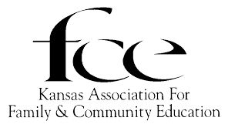

How Much Do You Know . . . .
About the Big O?

2019 KAFCE Lesson
Written by Susan Gartrell, KAFCE State EPC

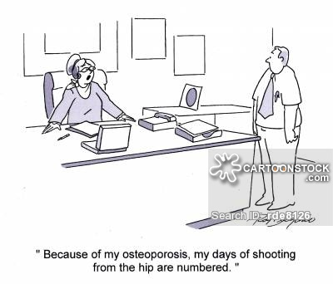
Osteoporosis is a disease we have been talking about for the last 25 years. Although much research has been done, and medications and hormone-related therapies have been developed, the sad truth is that the public in general remains unaware of the prevalence of this disease and the steps that can be taken to prevent osteoporosis from taking a bite out of the best years of our lives. This lesson can be used with Hearthfire Series lessons 13 and 13-A.

Educational Goals:
- Survey members to evaluate and review what they know about osteoporosis.
- Review population groups who are predisposed to bone loss and osteoporosis.
- Encourage individual members to schedule bone-density scans and/or talk about osteoporosis with their healthcare providers.
- Update knowledge on diets and dietary supplements that benefit bone health.
- Motivate members to include weight-bearing exercises in their weekly routines.

Community Action:
- Have an informative booth on osteoporosis at a local health fair.
- Sponsor an osteoporosis event for the community and invite speakers from the medical field.
- Provide funding for bone-density scans to be offered at the county fair.
- Give a lesson on osteoporosis for health classes at school or at a local youth meeting.
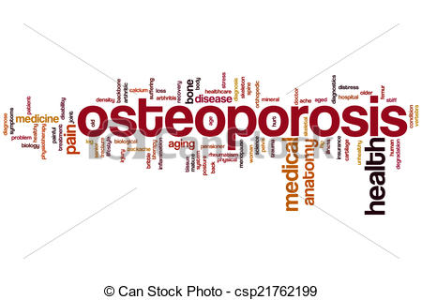
Boning Up - All About Bones
Without our bones we would be shapeless forms, unable to move or bear weight. Our bones serve as a pharmacy, storing minerals such as calcium and phosphorus, and dispensing minerals as needed by our bodies. The boney skeleton safeguards our organs; the skull protects our brain, the vertebrae encircle our spinal chord, and the ribs shield the heart and lungs.
There are two types of bone tissue: cortical, the dense, compact outer bone layer, and trabecular, the porous, spongy inner layer.
Bones are living tissue and change as we age through a process called bone modeling. Young bones slowly shift position. New bone forms on top of existing bone tissue at one site, at the same time, old bone tissue is removed from other sites. Bone growth is rapid in the very young. Through the 20's, skeletal growth slows and then stops. However, bone modeling continues throughout our lives. New bone is formed when needed to bridge a fracture, repair small cracks, or smooth deformities.
According to the U.S. Surgeon General, adult bone is entirely replaced approximately every ten years. Bone resorption may last only a few weeks, but bone formation is slower and can take up to four months.
When bone remodeling is imbalanced, the net result is reduced bone mass. Primary osteoporosis happens because at some point, we begin to lose more bone mass than we gain. This can be attributed to not enough calcium available to build new bone, to medicines or chemicals that accelerate bone tissue break down, or to an imbalance of the hormones that regulate body activities.

pg 1
Boning Up - Facts About Osteoporosis
Osteoporosis is known as the "silent disease." Because we can't see the shape our bones are in, many people ignore their risk factors and attribute back pains to other causes. Often people don't realize they have O until it reaches an advanced stage and they suffer a bone break. Even then people may not associate their bone fracture with the disease. In the U.S., a fracture caused by osteoporosis is estimated to occur every 15 minutes. Approximately 10 million Americans, 8 million women and 2 million men, already have O. In 2004, the U.S. Surgeon General’s office predicted that, if progress is not made to prevent the disease, by 2020, half of all Americans age 50 and over could be at risk for O. The latest data shows one women in two, and one man in four can expect to have a fracture as a result of O by the age of 80.

Boning Up - Who is at Risk? Everyone!!
There are several risk factors associated with O. Some can be overcome with lifestyle modifications and others cannot.
Age is the strongest of all risk factors in both men and women. We cannot change the aging process, but we can minimize age-related challenges.
Sex: Women are more likely to develop O because they have smaller bones to begin with and estrogen deficiency at menopause accelerates bone loss. But, men can develop osteoporosis, too. More women over the age of 55 are hospitalized every year in the U.S. due to an osteoporosis-related fracture than for heart attacks, strokes, and breast cancer combined.
Height & Weight: Body Mass Index is tied to bone density. Small, petite women usually have a higher risk, but tall, thin people are at risk also.
Ethnicity: O is more prevalent in Caucasians and Asians population, but people of all races can develop osteoporosis.
Family history: Know the diseases that run in your family so you can take preventative action early for diseases like O. Be sure to share your family health histories with the next generation.
Previous Fractures: Any bone fractures after the age of 45 could be early signs of O and increase your risk for another fracture. Fractures in children and younger people may indicate low bone mass as well.
Other Illnesses and the medications taken for those problems may cause bone loss and O. Taking care of yourself and working to maximize bone health can offset the risk of osteoporosis.
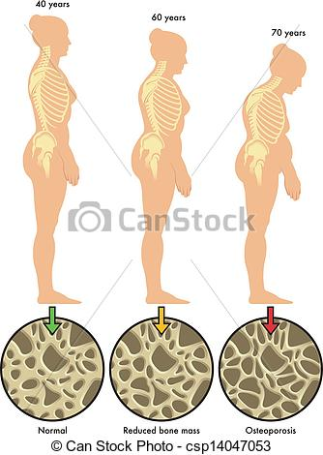
Boning Up - Bone Breaking News
Bone density loss can be triggered by several things. Food allegies that interfere with the digestive tract can reduce the absorption of important nutrients, like calcium, that are needed by bones and the body. Estrogen, testosterone, parathyroid hormone, and calcitonin are all hormones that regulate bone remodeling. The onset of menopause initiates an 8 - 10 year acceleration of bone loss in women because estrogen levels have been lowered in the body. Leading causes of osteoporosis in men include the use of steroids, antacids, and other medications, the presence of a chronic illness, and low levels of testosterone. Any factor that alters the balance of bone remodeling and the nutrients needed to build good bone can cause O.
Which comes first, the fracture or the fall? Brittle eroded bones can crack and break with any sudden or small movement, such as reaching down to pick up a grocery bag. Any bone can fracture from O, or osteoporosis, but the three most common sites of fraility fractures are the wrist, the spine, and the hip. More than 50% of bone fractures involve bones of the spine. Height loss of more than 1 1/2" could be an indication of cracked vertebrae. Hip fractures account for 25% of all bone fractures. Hip fractures among the elderly are ominous because they greatly reduce the patient's mobility and often lead to nursing home care. Statistic show that about 20% of patients die within 12 months of suffering a hip fracture. Once a person fractures a bone due to O, their risk of another break increases.

pg 2
Boning Up - Put Your Bones to the Test!!
There are ways of finding out if you are at risk for or have O before suffering a fractured bone. Using quantitative ultrasonography (QUS) or X-ray absorptiomety (DEXA), bone quality and the bone mass density (BMD) of the spine, hip, or forearm can be measured. The results of the scans are compared to the average bone mass of healthy individuals. Though this type of testing may or may not be covered by your health insurance, it is a worthwhile and practical way to find out if you have bone loss and gives you a head start on preventative measures.
Any one who has suffered a recent fracture, or lost more than an inch and a half of height, or suffers acute or chronic pain in the middle or upper back should probably have a bone density test done.
It is also recommended that pre-menopausal women have baseline bone density tests done to help decide about hormone-related treatments as they go through menopause.
The NOF recommends the following have a bone-density measurement taken: a) All women age 65 and over; b) postmenopausal women under the age of 65 who have one or more risk factors for O;
c) postmenopausal women who have had a fracture; d) women who have been taking ERT or HRT for prolonged periods; and e) women who are considering therapy for O when knowledge of bone density would aid in that decision.

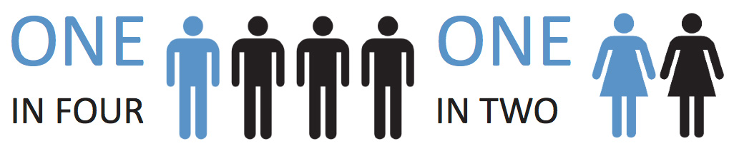

Boning Up - When Should Prevention Begin?
Osteoporosis is a disease that only affects the older population, right? Wrong! Osteoporosis is truly a childhood disease because that is the period in our lives when bone development begins. The frame- work for strong adult bones starts with building enough bone mass in our youth and young adult years. Although genetics play a big part, lifestyle choices can influence bone health significantly.

For example, as much as 40% of total adult bone mass is accumulated during a period of rapid bone growth during adolescence. The risk of not attaining healthy bone mass is heightened by poor lifestyle choices among teenagers. Most youths do not come close to meeting their daily recommended amounts of calcium and vitamin D. More time is spent on the computer and electronic devices at the expense of physical activity; and cigarette smoking is a common habit adopted by this age group. Along with poor food choices, soda drinks often replace milk or other more nutritious beverages.
Prevention is the best strategy to combat the pending threat of osteoporosis in our aging society. We need to give our bones the attention and support they need throughout our lifetime, and they will continue to support us into our older years.

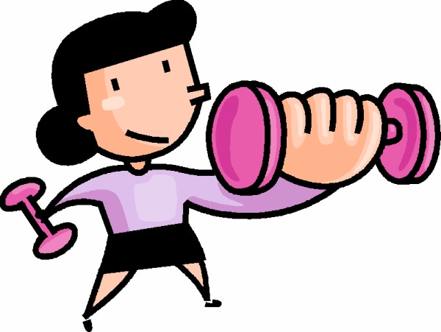
Boning Up - Bone Building Strategies!!
If diagnosed in time, O can be prevented and bone loss reversed. A successful plan to prevent or treat O involves: proper nutrition with sufficient intake of calcium and vitamin D, regular physical activity, and medical checkups to determine if hormonal support or medications are needed.
Getting adequate amounts of calcium, vitamin D, and other necessary vitamins and minerals is important for growing and maintaining bone mass. With an estimated average daily intake of 500 mg, most adult diets are deficient in calcium. Recom- mended calcium requirements for adult men and women are closer to 1000 - 1500 mg/day. People can get vitamin D from the fortified foods in their diet and from the sun if they are involved in outdoor activities. Most diets are deficient in vitamin D as well, so some physicians recommend taking a calcium supplement with vitamin D3, plus a multivitamin to get the levels of nutrients needed.
Common calcium supplements include calcium carbonate and calcium citrate. Check the label to see how much elemental calcium is actually available. Calcium carbonate must be taken with food to insure absorption by the body.

pg 3
Boning Up - Exercise Boosts Bone Health
The more active we are, the stronger our bones will be. Adults need to set aside 30 minutes each day for physical activities that incorporate aerobic exercise and strength training, as well as activities to improve flexibility and balance. Exercises that target body areas, such as the back or wrist can strengthen the muscles in that area to help support bones, plus stimulate bone growth. Improving body strength and balance will help prevent the likelihood of a bone-breaking fall.

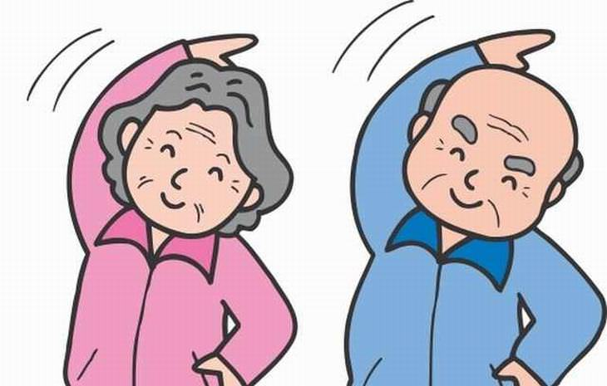

Many communities have a fitness center or offer classes to help get an exercise program started. Ask your physician for advice on what exercises are appropriate for you.

Boning Up - On Treatment Options
Through medical trials and scientific research, progress has been made in designing treatment programs for osteoporosis. Possible treatment strategies include hormone replacement therapy as well as a long list of medications that either prevent bone resorption by osteoclasts, or enhance bone building by osteoblasts. Each person's bone history is unique, so no one treatment works for everyone, and side effects must be considered. If you are at high-risk for bone loss, medication can improve your odds. Gather as much information as you can from reliable resources and be sure to consult with your doctor to work out the treatment plan best suited for you.

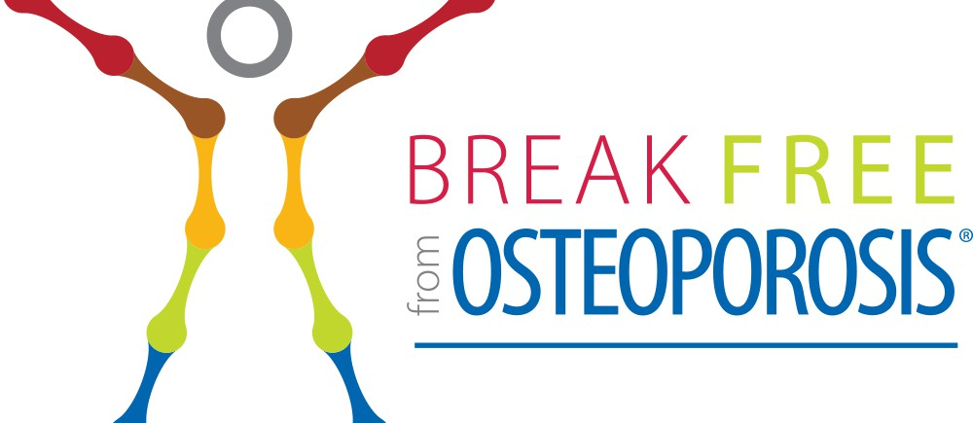
Boning Up - Doing a Personal Assessment
Let's stop talking about osteoporosis and instead start taking action! We can begin by personally assessing our overall health and habits. Then we can set goals for the changes we need to make to keep our bones healthy and reduce the chances of big O interfering with our lives. At least once each year:
1. Measure your height.
2. Weigh yourself and determine your BMI.
3. Take a balance test.
4. Asses your eating habits. Are you getting enough calcium and vitamin D, and consuming the recommended amounts of fruits and vegetables?
5. Evaluate your level of physical activity and calculate time spent on strength training and weight bearing activities.
6. Update your medical records with latest results from mammograms, bone density tests, etc. Include a list of medications regularly taken, current medical conditions, and other routine tests or immunizations.
7. Make an appointment for your annual medical checkup.
8. Check your home for potential safety hazards that could cause a fall.
9. Think about your overall lifestyle. What other changes would lead to better health?
10. Celebrate your healthy accomplishments and set goals for the changes needed.

References and Resources:
National Osteoporosis Foundation, www.nof.org.
The Complete Book of Bone Health, by Diane L Schneider, M.D., Prometheus Books, N.Y., 2011
The Cleveland Guide to Osteoporosis, by Abby Abelson, M.D., Kaplan Publishing, 2010
Strong Women, Strong Bones, by Miriam E. Nelson, Ph. D., Penguin Group, Inc., 2006
Skeletal Fitness - A Workout for Your Bones by Mirabai Holland, DVD, 2004
Mayo Clinic on Osteoporosis, S. Hodgson, M.D., 2003
I'm Not Slowing Down by Ann Richards, (Winning My Battle with Osteoporosis), Dutton Adult, NY, 2003
The Bone Density Diet, by George Kessler, M.D., Ballantine Books, 2000
Preventing and Reversing Osteoporosis, Alan R. Gaby M.D., Harmony Books, 1995

This lesson was reviewed by:
Jean Ann Hoeting, RN, BSN, Rooks Co Health Dept

pg 4

