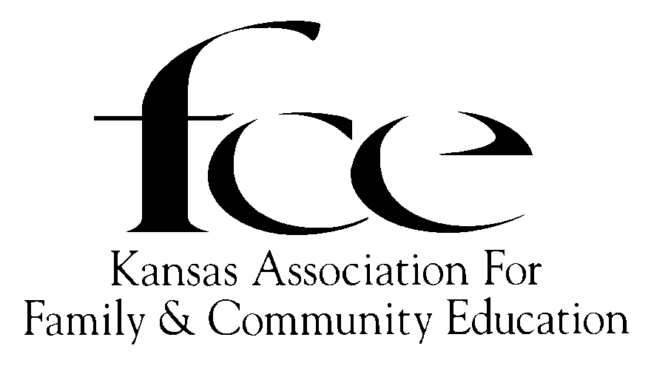

Proclamation

WHEREAS, Kansas Association for Family and Community Education is an independent nonprofit organization instituted for the purpose of enriching Kansas families; and

WHEREAS, the mission of the Kansas Association for Family and Community Education is strengthening individuals, families and communities through: *continuing education *developing leadership *community action; and

WHEREAS, in Kansas during the past year 44 counties with 84 FCE groups and approximately 900 members received continuing education through family and community education;

NOW, THEREFORE, I, Laura Kelly, GOVERNOR OF THE STATE OF KANSAS, do hereby proclaim October 13-19, of 2019, as

KANSAS FAMILY AND
COMMUNITY EDUCATION WEEK

in Kansas and urge all citizens to join in this observation.

